This table shows the connections that are the basis for the probability rules in this chapter.

|  |  |  |  |
| --- | --- | --- | --- |
|  | **Set Theory** | **Logic** | **Arithmetic** |
| Section 11.2  Operation  Connective Symbol | Compliment  ( **′** ) | Not  ( **~** ) | Subtraction  ( **–** ) |
| Section 11.2  Operation  Connective Symbol | Union  ( **∪** ) | Or  ( **V** ) | Addition  ( **+** ) |
| Section 11.3  Operation  Connective Symbol | Intersection  ( **∩** ) | And  ( **Ʌ** ) | Multiplication  ( • ) |

**1. Events Involving “NOT”**

The probability of an event ***not*** happening involves the *compliment* and *subtraction* of probabilities.

**Probability of a Compliment – “NOT”**

The probability that an event (*E*) will ***not*** occur is equal to one minus the probability that an event will occur, (the opposite). Look at the Venn diagram of probability.

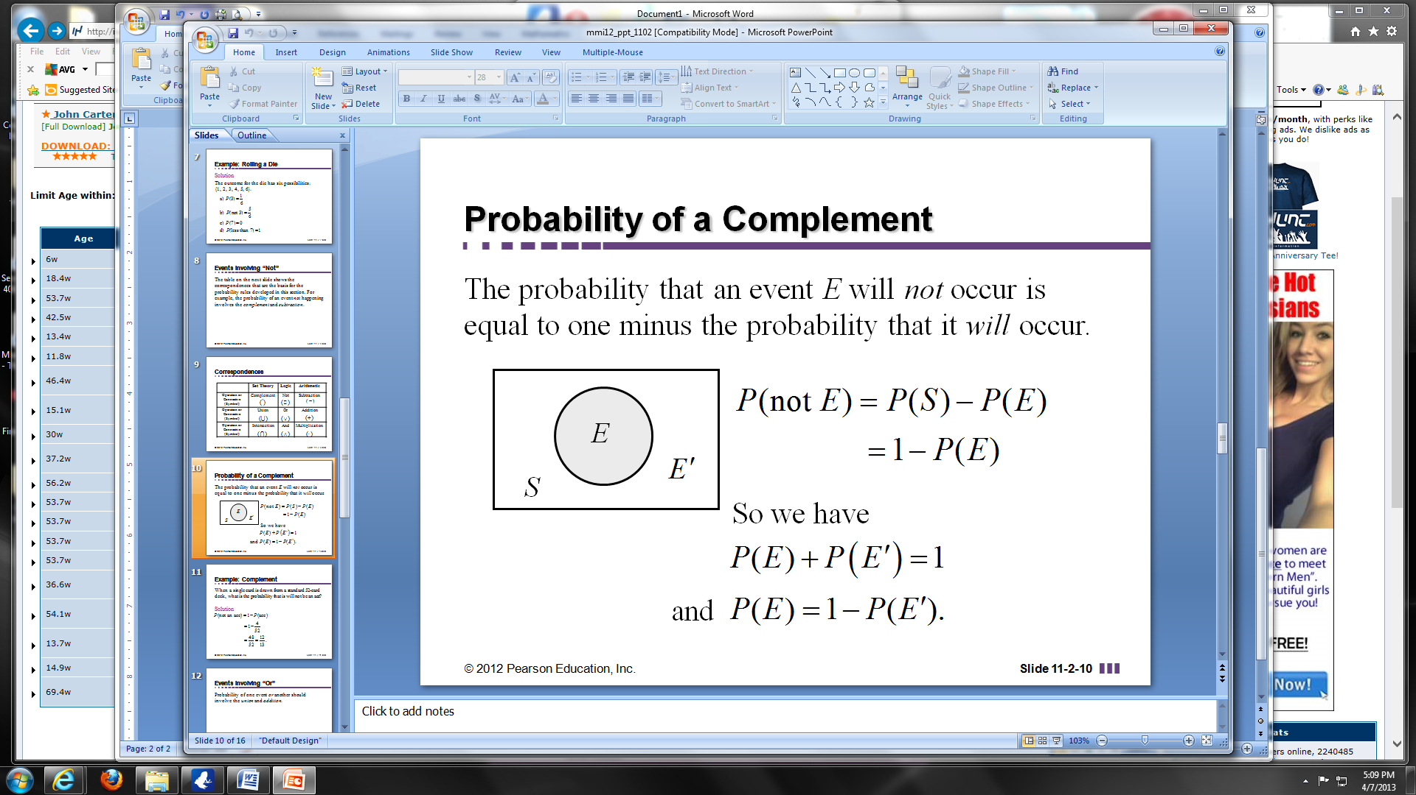

*P*(not *E*) = 1 – *P*(*E*)

Because, *P*(*E*)+ *P*(*E′* )= 1

Basically, it involves subtraction.

**EXAMPLE:** The probability that it will rain today is 75% or 0.75. What is the probability that it will not rain today?

**EXAMPLE:** The distribution of degrees conferred at a local college is listed in the table to the right. What is the probability that a randomly selected student’s degree is not in liberal arts?

|  |  |
| --- | --- |
| Business | 1676 |
| Chemistry | 318 |
| Engineering | 868 |
| English | 2073 |
| Liberal Arts | 1358 |
| Mathematics | 2164 |
| Physics | 856 |

**EXAMPLE:** A single card is drawn from a standard 52-card deck. Answer the following questions:

1. ● What is the probability that your one card is not an ace?

● What are the odds in favor of not drawing an ace?

1. ● What is the probability that your one card is not a diamond?

● What are the odds in favor of not drawing a diamond?

1. ● What is the probability that your one card will not be red?

● What are the odds in favor of not drawing a red card?

**2. Events Involving “OR”**

The probability of one event **OR** another event happening involves the *union* and *addition* of probabilities. Remember **OR** involves one or the other or both.

If two events have nothing in common (disjoint), then the two events, event *A* and event *B*, are said to be _____________ ______________ events. This means they have *___ outcomes in common*.

**Probability for *A* “or” *B* uses the addition rule:**

(1) If A and B are mutually exclusive (have nothing in common) then add their probabilities:

***P*(*A* or *B*) = *P*(*A*) + *P*(*B*)**

(2) If A and B are two events with something in common then add their probabilities and subtract what they have in common:

***P*(*A* or *B*) = *P*(*A*) + *P*(*B*) – *P*(*A* and *B*)**

Duplicate numbers (numbers being repeated) are subtracted. You CANNOT count the same thing twice.

**EXAMPLE:** For the experiment of drawing a single card from a standard 52-card deck, find the **(a)** probability of the event below, and **(b)** the odds in favor of the given event.

Ace or Jack

* How many Aces? ____________ ● How many Jacks? _______________
* Mutually exclusive? (anything in common) _______________________________
* Total number of cards in the deck _________________________________
* **(a)** Calculate the probability of drawing an Ace or a Jack:
* **(b)** Calculate the odds in favor of drawing an Ace or a Jack:

**EXAMPLE:** If a single, six-sided die is rolled, what is the probability of rolling a number greater than 4 or less than 3?

* How many ways to roll greater than 4? _________________________________
* How many ways to roll less than 3? _________________________________
* Mutually exclusive? (anything in common) _______________________________
* Total number of outcomes _________________________________
* Calculate the probability of rolling a number greater than 4 or less than 3:

**EXAMPLE:** For the experiment of rolling an ordinary pair of dice, find the probability that the sum will be less than 4 or greater than 7.

* How many ways sum less than 4? _____________________________________________
* How many ways sum greater than 7?

|  |  |  |  |  |  |
| --- | --- | --- | --- | --- | --- |
| Sum 8 | Sum 9 | Sum 10 | Sum 11 | Sum 12 | Total |
|  |  |  |  |  |  |

* Mutually exclusive? (anything in common) _______________________________
* Total number of outcomes rolling 2 dice _________________________________
* Calculate the probability of rolling a sum less than 4 or greater than 7:

**EXAMPLE:** A lottery game has balls numbered 0 through 13. If a ball is selected at random, what is the probability of selecting an even numbered ball or a 3?

* How many even numbered balls? _________________________________
* How many balls numbered “3”? _________________________________
* Mutually exclusive? (anything in common) __________________________
* Total number of lottery balls _________________________________
* Calculate the probability of selecting even numbered ball or a 3:

**EXAMPLE:** For the experiment of drawing a single card from a standard 52-card deck, find the **(a)** probability of the event below, and **(b)** the odds in favor of the given event.

spade or face card

* How many spades? ____________ ● How many face cards? ______________
* Mutually exclusive? (anything in common) _______________________________
* Total number of cards in the deck _________________________________
* **(a)** Calculate the probability of drawing a spade or a face card:
* **(b)** Calculate the odds in favor of drawing a spade or a face card:

**EXAMPLE:** For the experiment of rolling an ordinary pair of dice, find the probability that the sum will be odd or a multiple of 3?

* How many specific ways can the sum be odd?

|  |  |  |  |  |  |
| --- | --- | --- | --- | --- | --- |
| Sum 3 | Sum 5 | Sum 7 | Sum 9 | Sum 11 | Total |
|  |  |  |  |  |  |

* How many specific ways can the sum be a multiple of 3?

|  |  |  |  |  |
| --- | --- | --- | --- | --- |
| Sum 3 | Sum 6 | Sum 9 | Sum 12 | Total |
|  |  |  |  |  |

* Mutually exclusive? (anything in common) ______________________________________
* Total number of outcomes rolling a pair of dice?_________________________________
* Calculate the probability that the sum will be odd or a multiple of 3:

**EXAMPLE:** For the experiment of drawing a single card from a standard 52-card deck, find the **(a)** probability of the event below, and **(b)** the odds in favor of the given event.

Neither a heart nor a king or queen

* How many hearts? ____________ ● How many kings or queens? _______________
* Mutually exclusive? (anything in common) _______________________________
* Total number of cards in the deck _________________________________
* **(a)** Calculate the probability of drawing neither a heart nor a king or queen:

* **(b)** Calculate the odds in favor of drawing neither a heart nor a king or queen: